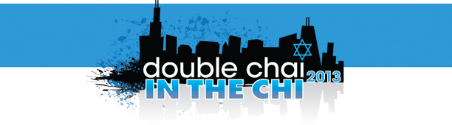
Call for nominations for Chicago's second annual Jewish 36 under 36 list!

Nominate an extraordinary Jew you know to be a part of Chicago's second annual Jewish 36 under 36 list. Winners will be announced and profiled July 16 on Oy!Chicago and highlighted at YLD's WYLD party on August 8.

How to apply: To submit your nomination, please complete this form and email it to DoubleChai@oychicago.com by noon on Tuesday, May 28.

Your information:

Full Name:
Email: |  | Phone:

Nominee’s information:

Full Name:
Email: |  |  | Phone:
Date of Birth:
Occupation:
Relationship to nominee:

First three words that come to mind when you think of this person:
1. |  | 2. |  | 3.

How has this person made a difference? (200 words or less):

Why is this person a Jew we should know? (200 words or less):

What else do we need to know? (200 words or less):

